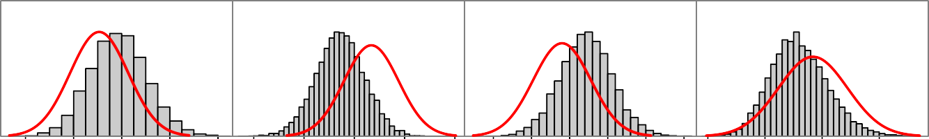

MGparm[1]

ESS=913 Rhat=1.009

MGparm[3]

ESS=462 Rhat=1.024

MGparm[4]

ESS=1038 Rhat=1.018

MGparm[5]

ESS=1913 Rhat=1.006

0.14 0.16 0.18 0.20 0.22 47.0 47.5 48.0 48.5 49.0 0.185 0.195 0.205 0.09 0.10 0.11 0.12

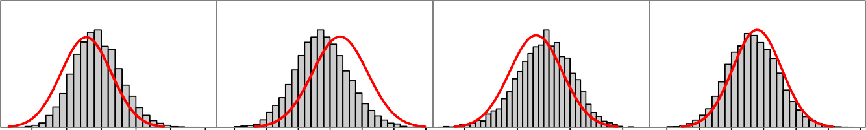

MGparm[6]

ESS=1993 Rhat=1.003

MGparm[13]

ESS=1005 Rhat=1.011

MGparm[15]

ESS=985

Rhat=1.01

MGparm[16]

ESS=1159 Rhat=1.005

0.030 0.040 0.050

0.10 0.20 0.30 0.40 −0.36 −0.34 −0.32 −0.30

0.40 0.50 0.60 0.7

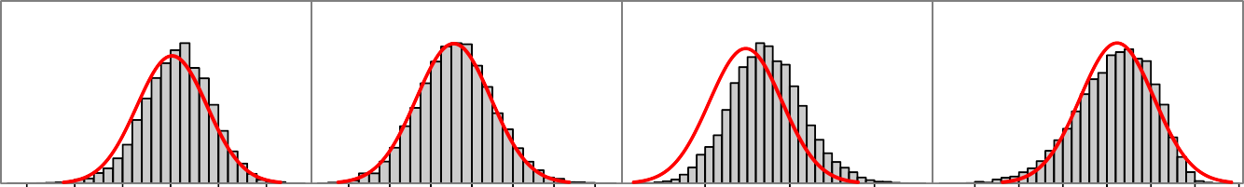

MGparm[17]

ESS=1379 Rhat=1.003

MGparm[18]

ESS=1190 Rhat=1.004

SR_parm[1]

ESS=842 Rhat=1.013

recdev2[1]

ESS=1033 Rhat=1.004

−0.1 0.1 0.2 0.3 0.4

−0.4 0.0 0.4 0.8

10.0 10.5 11.0

−3 −2 −1 0 1 2 3

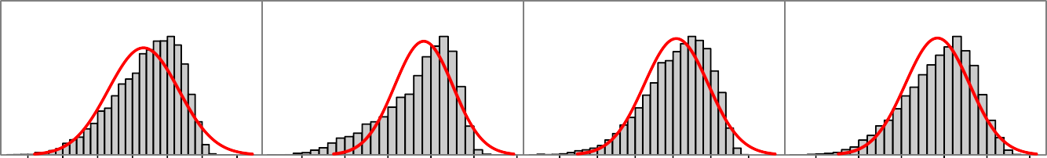

recdev2[2]

ESS=729 Rhat=1.011

recdev2[3]

ESS=221 Rhat=1.034

recdev2[4]

ESS=652 Rhat=1.011

recdev2[5]

ESS=792 Rhat=1.013

−3 −2 −1 0 1 2 3

−2 −1 0 1 2 3

−3 −2 −1 0 1 2

−3 −2 −1 0 1 2

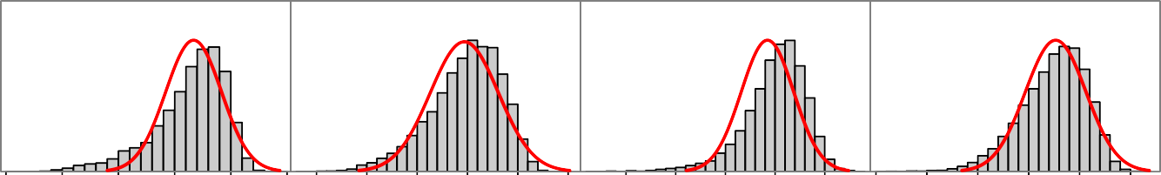

recdev2[6]

ESS=320 Rhat=1.026

recdev2[7]

ESS=789 Rhat=1.004

recdev2[8]

ESS=585 Rhat=1.007

recdev2[9]

ESS=901 Rhat=1.006

−3 −2 −1 0 1 2

−3 −2 −1 0 1 2

−0.5 0.0 0.5 1.0 1.5

−4 −3 −2 −1 0 1

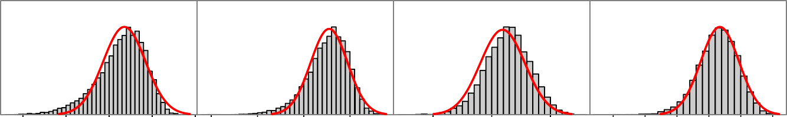

recdev2[10]

ESS=891 Rhat=1.004

recdev2[11]

ESS=998 Rhat=1.009

recdev2[12]

ESS=1224 Rhat=1.009

recdev2[13]

ESS=1404 Rhat=1.003

−3 −2 −1 0 1 −3 −2 −1 0

0.0 0.5 1.0

−2.0 −1.0 0.0 0.5

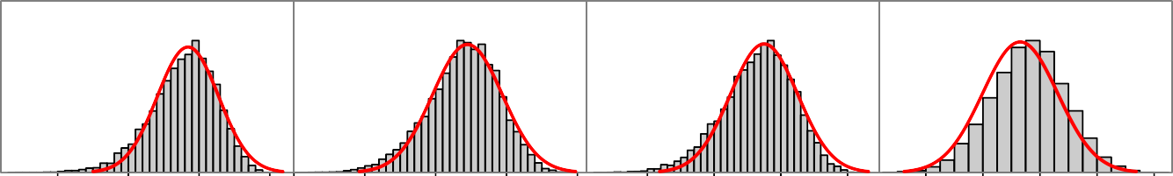

recdev2[14]

ESS=1095 Rhat=1.007

recdev2[15]

ESS=1745 Rhat=1.004

recdev2[16]

ESS=1365 Rhat=1.007

recdev2[17]

ESS=1194 Rhat=1.012

−3 −2 −1 0 −4 −3 −2 −1 0

−3 −2 −1 0

1.2 1.4 1.6 1.8 2.0

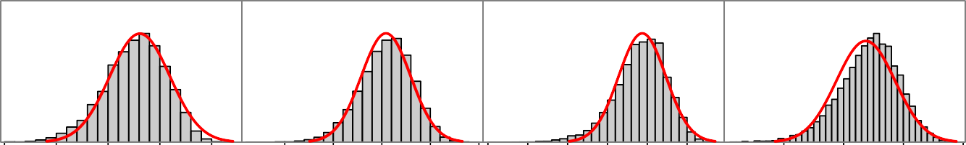

recdev2[18]

ESS=1588 Rhat=1.007

recdev2[19]

ESS=1338 Rhat=1.007

recdev2[20]

ESS=1020 Rhat=1.007

recdev2[21]

ESS=1192 Rhat=1.003

−4 −3 −2 −1 0

−1.0 −0.5 0.0 0.5 1−.02.0 −1.0 0.0 0.5

−0.5 0.0 0.5 1.0

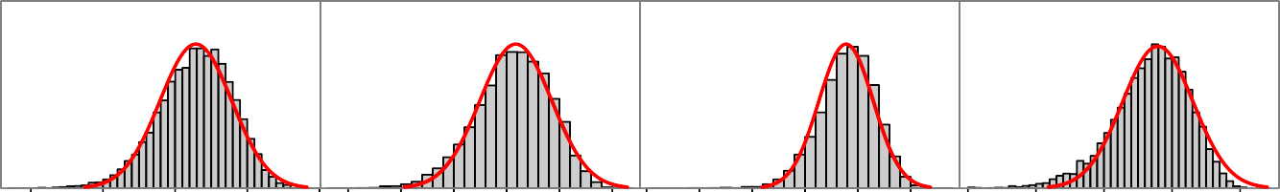

recdev2[22]

ESS=1447 Rhat=1.002

recdev2[23]

ESS=1487 Rhat=1.002

recdev2[24]

ESS=1314 Rhat=1.007

recdev2[25]

ESS=1476 Rhat=1.005

−1.0 −0.5 0.0 0.5 1.0−2.0 −1.0 0.0 0.5−2.0 −1.0 0.0 0.5 −4 −3 −2 −1 0

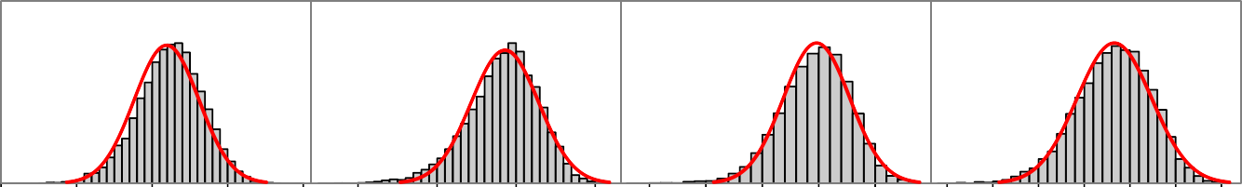

recdev2[26]

ESS=1446 Rhat=1.005

recdev2[27]

ESS=1418 Rhat=1.003

recdev2[28]

ESS=1362 Rhat=1.007

recdev2[29]

ESS=1579 Rhat=1.007

1.0 −0.5 0.0 0.5 1.0

−3 −2 −1 0

−2.0 −1.5 −1.0 −0.5 0.0

−3.0 −2.0 −1.0 0.0

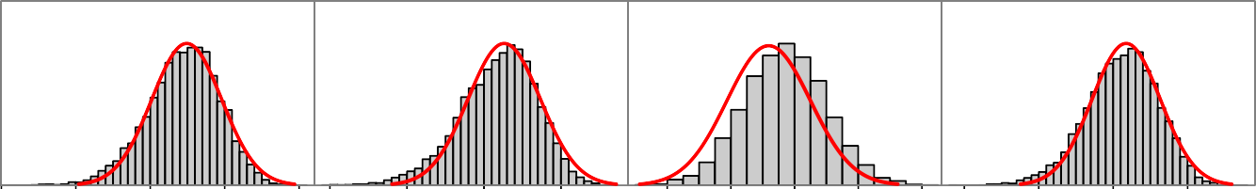

recdev2[30]

ESS=1467 Rhat=1.001

recdev2[31]

ESS=1405 Rhat=1.005

recdev2[32]

ESS=2337 Rhat=1.005

recdev2[33]

ESS=1207 Rhat=1.007

−4 −3 −2 −1 0

−3 −2 −1 0

2.0 2.2 2.4 2.6 2.8

−3 −2 −1 0

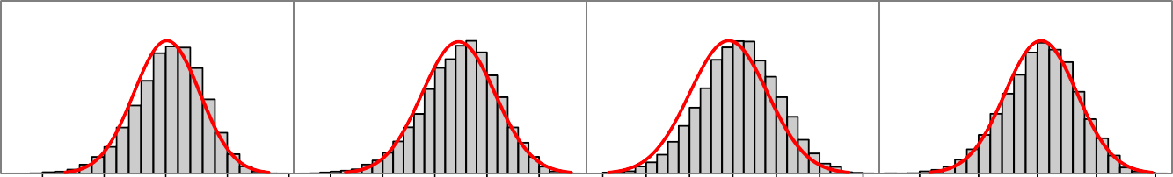

recdev2[34]

ESS=1362 Rhat=1.007

recdev2[35]

ESS=1528 Rhat=1.005

recdev2[36]

ESS=1778 Rhat=1.005

recdev2[37]

ESS=1612 Rhat=1.006

−1.0 −0.5 0.0 0.5 1.0 −2.0 −1.0 0.0

0.0 0.2 0.4 0.6 0.8 1.0 1.2

−2.0 −1.5 −1.0 −0.5 0.0

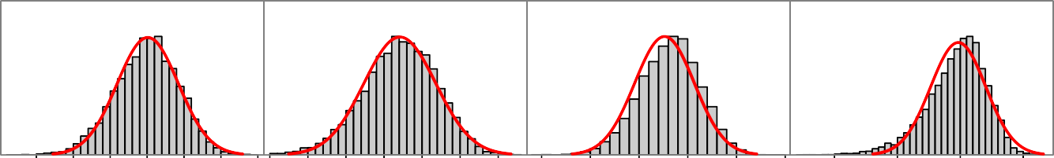

recdev2[38]

ESS=1850 Rhat=1.003

recdev2[39]

ESS=2088 Rhat=1.002

recdev2[40]

ESS=1399 Rhat=1.003

recdev2[41]

ESS=1167 Rhat=1.007

−3.5 −2.5 −1.5 −0−.45.0 −3.0 −2.0 −1.0 −2.0 −1.5 −1.0 −0.5 0.0 0.5 −3 −2 −1 0

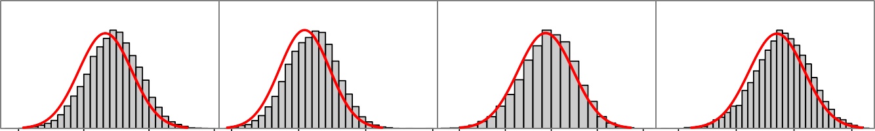

recdev2[42]

ESS=1423 Rhat=1.006

recdev2[43]

ESS=1607 Rhat=1.006

recdev2[44]

ESS=1581 Rhat=1.002

recdev2[45]

ESS=1392 Rhat=1.004

0.0 0.5 1.0 1.50.5 1.0 1.5 2.0 −1.0 −0.5 0.0 0.5 1.0 0.0 0.5 1.0 1.5

1.0 1.5 2.0

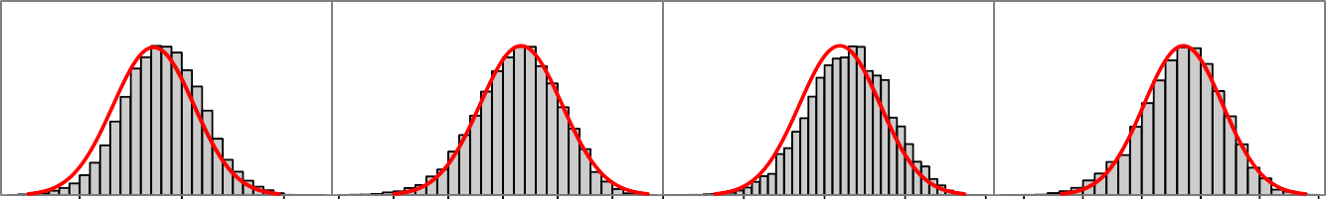

recdev2[46]

ESS=1807 Rhat=1.005

recdev2[47]

ESS=1539 Rhat=1.009

recdev2[48]

ESS=1654 Rhat=1.003

recdev2[49]

ESS=1258 Rhat=1.005

−2.0 −1.0 0.0 0.5

−0.5 0.0 0.5 1.0 1.5 −1.5 −0.5 0.0 0.5 1.0

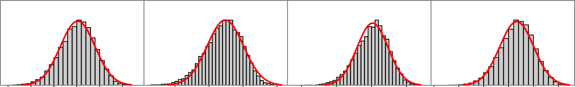

recdev2[50]

ESS=1506 Rhat=1.002

recdev2[51]

ESS=1814 Rhat=1.005

recdev2[52]

ESS=1400 Rhat=1.002

recdev2[53]

ESS=1717 Rhat=1.003

−2.0 −1.0 0.0 0.5

−3 −2 −1 0

−3 −2 −1 0

−2.0 −1.0 0.0 0.5

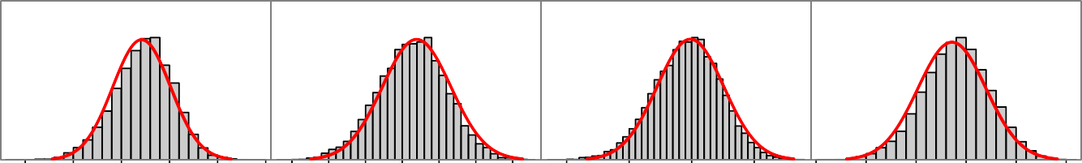

recdev2[54]

ESS=1617 Rhat=1.005

recdev2[55]

ESS=1692 Rhat=1.004

recdev2[56]

ESS=1667 Rhat=1.004

recdev2[57]

ESS=1563 Rhat=1.003

−1.0 0.0 0.5 1.0 1.5−2.5 −1.5 −0.5 0.5

−2 −1 0 1

−2 −1 0 1 2 3

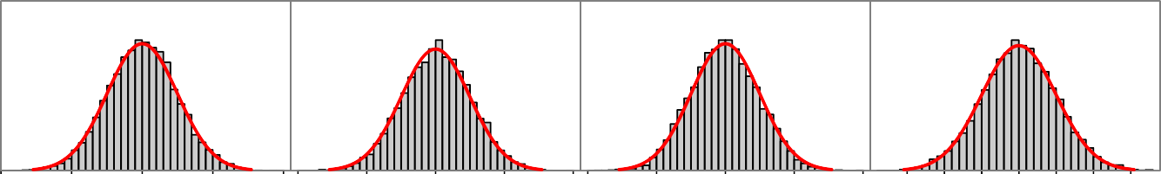

Fcast_recruitments[

ESS=1488

Rhat=1.002

1] Fcast_recruitments[

ESS=1427

ESS=1562

ESS=1440

Rhat=1.003

2] Fcast_recruitments[

Rhat=1.005

3] Fcast_recruitments[

Rhat=1.005

4]

−4 −2 0 2 4−4 −2 0 2 4−4 −2 0 2 4 −3 −2 −1 0 1 2 3

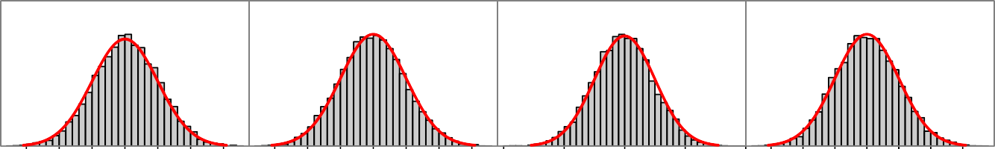

Fcast_recruitments[

ESS=1712

Rhat=1.002

5] Fcast_recruitments[

ESS=1707

ESS=1517

ESS=1434

Rhat=1.004

6] Fcast_recruitments[

Rhat=1.005

7] Fcast_recruitments[

Rhat=1.009

8]

−3 −2 −1 0 1 2 3

−3 −2 −1 0 1 2 3

−4 −2 0 2 4

−3 −2 −1 0 1 2 3

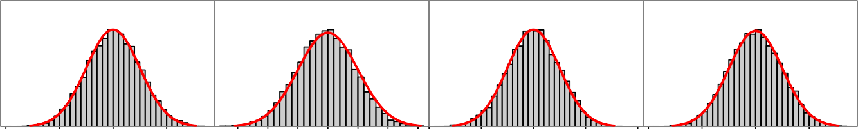

Fcast_recruitments[

ESS=1528

Rhat=1.002

9] Fcast_recruitments[

ESS=1774

ESS=1739

ESS=1611

Rhat=1.004

10] Fcast_recruitments[

Rhat=1.003

11] Fcast_recruitments[

Rhat=1.003

12]

−4 −2 0 2 −3 −2 −1 0 1 2 3−4 −2 0 2 4−4 −2 0 2

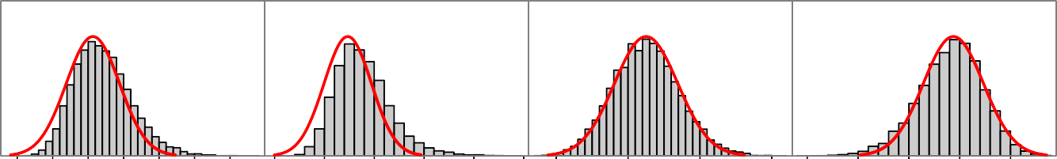

Q_parm[6]

ESS=1242 Rhat=1.003

Q_parm[8]

ESS=932 Rhat=1.007

selparm[1]

ESS=1037

Rhat=1.01

selparm[3]

ESS=825

Rhat=1.01

0.1 0.3 0.5 0.7

0.5 1.0 1.5 2.0 2.5 3.0

35 40 45 50

3.0 3.5 4.0 4.5 5.0

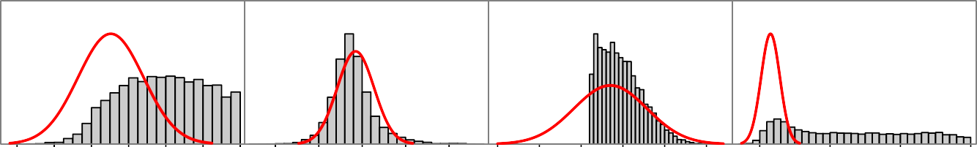

selparm[4]

ESS=469 Rhat=1.017

selparm[7]

ESS=224

Rhat=1.02

selparm[9]

ESS=566 Rhat=1.009

selparm[10]

ESS=31 Rhat=1.251

0 2 4 6 8 10 12

15 20 25 30 35

−4 −2 0 2 4 6

5 10 15 20

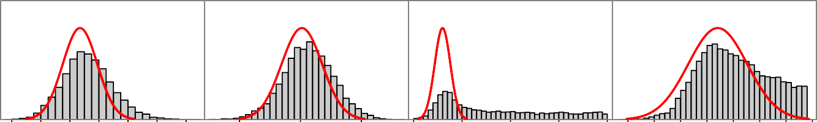

selparm[13]

ESS=699 Rhat=1.008

selparm[15]

ESS=726 Rhat=1.009

selparm[16]

ESS=10 Rhat=1.354

selparm[19]

ESS=518 Rhat=1.008

40 42 44 46 48 50 52

4.0 4.5 5.0

0 5 10 15 20 25 30 35 40 45 50 55 60

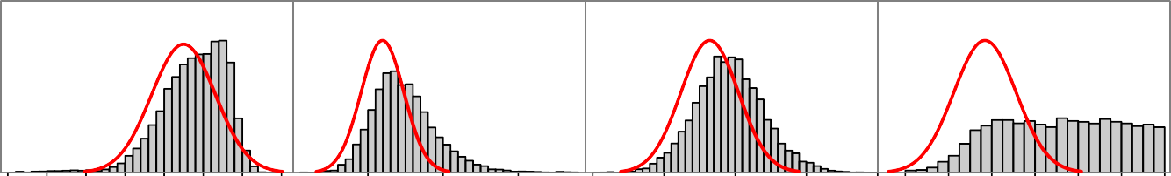

selparm[21]

ESS=411 Rhat=1.012

selparm[25]

ESS=661 Rhat=1.011

selparm[27]

ESS=748 Rhat=1.012

selparm[28]

ESS=363 Rhat=1.017

0 1 2 3 4 5 6 7

45 50 55

3.5 4.0 4.5 5.0 5.5 0 2 4 6 8 10 12

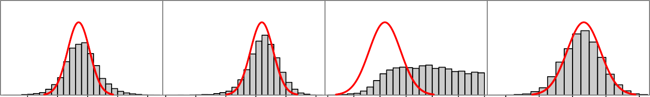

selparm[31]

ESS=618 Rhat=1.017

selparm[33]

ESS=554 Rhat=1.018

selparm[34]

ESS=186 Rhat=1.035

selparm[37]

ESS=462

Rhat=1.02

35 40 45 50 55 3.5 4.0 4.5 5.0 5.5 6.0 0 2 4 6 8 10 12 20 22 24 26 28

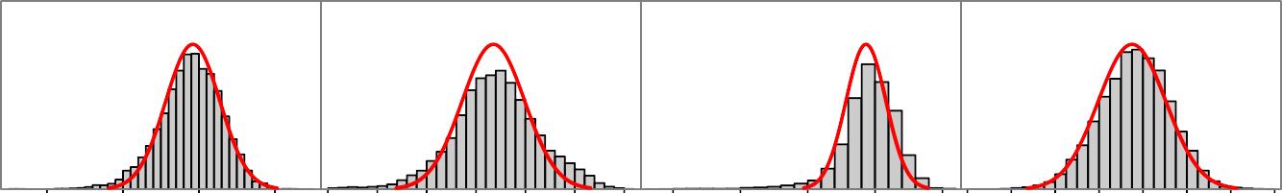

selparm[39]

ESS=549 Rhat=1.013

selparm[40]

ESS=243 Rhat=1.038

selparm[42]

ESS=152 Rhat=1.031

selparm[43]

ESS=1160 Rhat=1.006

1 2 3 4

0 1 2 3 4 5 6

−4 −3 −2 −1 0 22 24 26 28 30 32 34 36

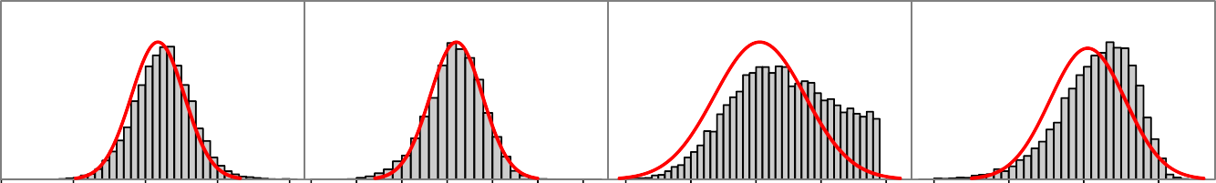

selparm[45]

ESS=964 Rhat=1.006

selparm[46]

ESS=1061 Rhat=1.005

selparm[51]

ESS=1300 Rhat=1.012

selparm[52]

ESS=869 Rhat=1.013

2 3 4 5 6 0 1 2 3 4 5 6

40 45 50 55 60

2 3 4 5

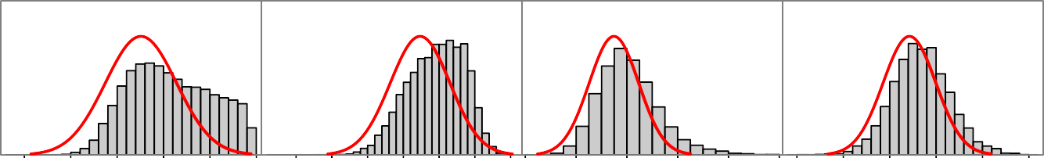

selparm[54]

ESS=1130 Rhat=1.009

selparm[55]

ESS=1197 Rhat=1.006

selparm[57]

ESS=558 Rhat=1.012

selparm[58]

ESS=687 Rhat=1.012

35 40 45 50 55 60 3.0 4.0 5.0 6.030 32 34 36 38 402.0 2.5 3.0 3.5 4.0 4.5

selparm[60]

ESS=842 Rhat=1.007

selparm[61]

ESS=1045 Rhat=1.006

25 30 35 40 2 3 4 5 6